**PROJECT REPORT TEMPLATE *1.INTRODUCTION:***

***1.1 OVERVIEW:***

Starting a new company can be an exciting and rewarding experience, but it also requires careful planning and analysis to ensure that the business is viable and successful. There are several key areas that you should focus on when conducting a startup company analysis. Conducting a thorough analysis of these areas can help you identify potential challenges and opportunities, and develop strategies to address them. It is also important to regularly review and update your analysis as the business progresses, in order to adapt to changing market conditions.

***1.2 PURPOSE:***

**To accomplish this, we have to complete all the activities listed below,**

* **Define Problem / Problem Understanding**
  + **Specify the business problem**
  + **Business requirements**
  + **Literature Survey**
  + **Social or Business Impact.**
* **Data Collection & Extraction from Database**
  + **Collect the dataset,**
  + **Storing Data in DB**
  + **Perform SQL Operations**
  + **Connect DB with Tableau**
* **Data Preparation**
* **Prepare the Data for Visualization**
* **Data Visualizations**
  + **No of Unique Visualizations**
* **Dashboard**
  + **Responsive and Design of Dashboard**
* **Story**
  + **No of Scenes of Story**
* **Performance Testing**
  + **Amount of Data Rendered to DB ‘**
  + **Utilization of Data Filters**
  + **No of Calculation Fields**
  + **No of Visualizations/ Graphs**
* **Web Integration**
  + **Dashboard and Story embed with UI With Flask**
* **Project Demonstration & Documentation**
  + **Record explanation Video for project end to end solution**
  + **Project Documentation-Step by step project development procedure.**

***2.1 EMPATHYMAP SCREEN SHOT:***

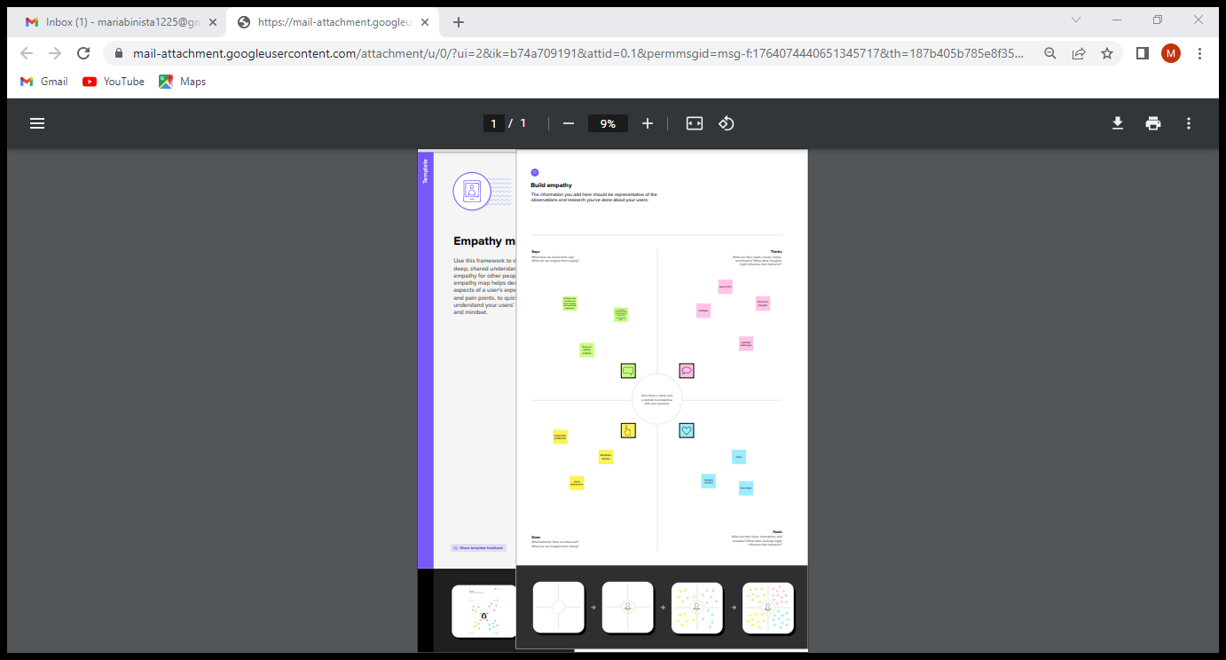

***2.2 BRAINSTROMING SCREEN SHOT:***

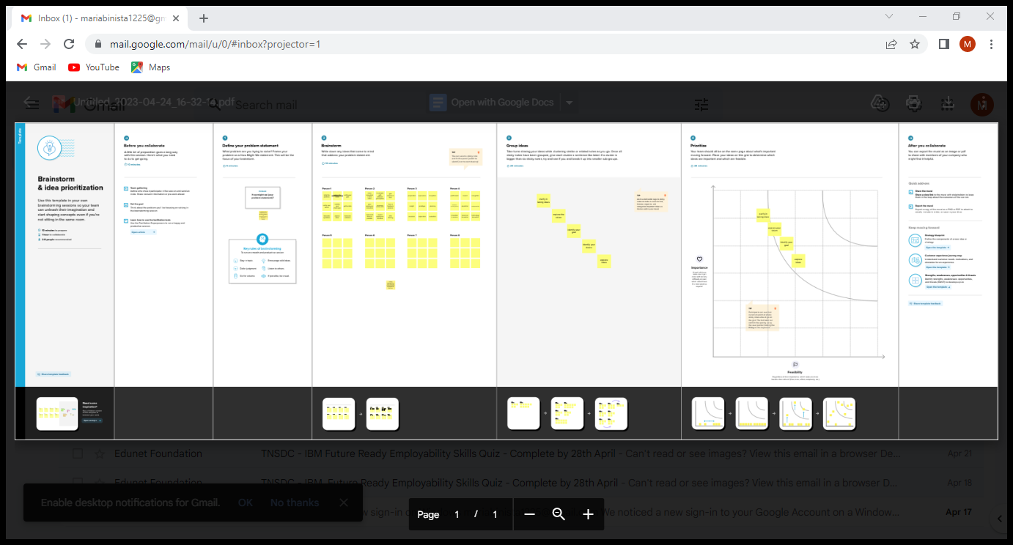

***3. DASHBOARD AND STORY SCREEN SHOT:***

***3.1 Dashboard:***

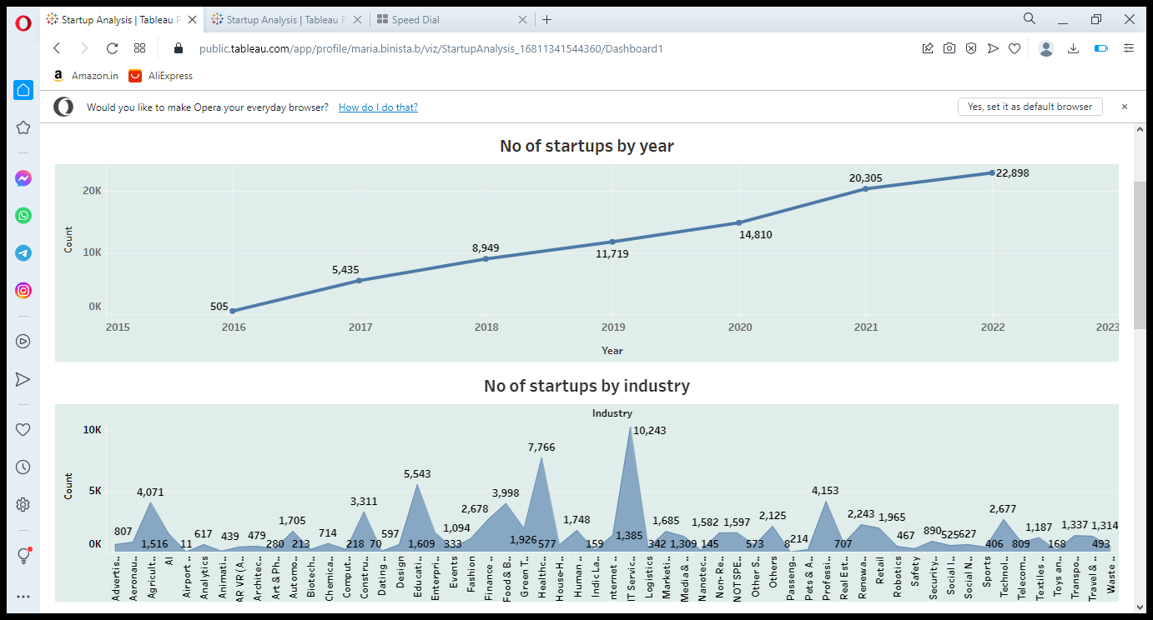

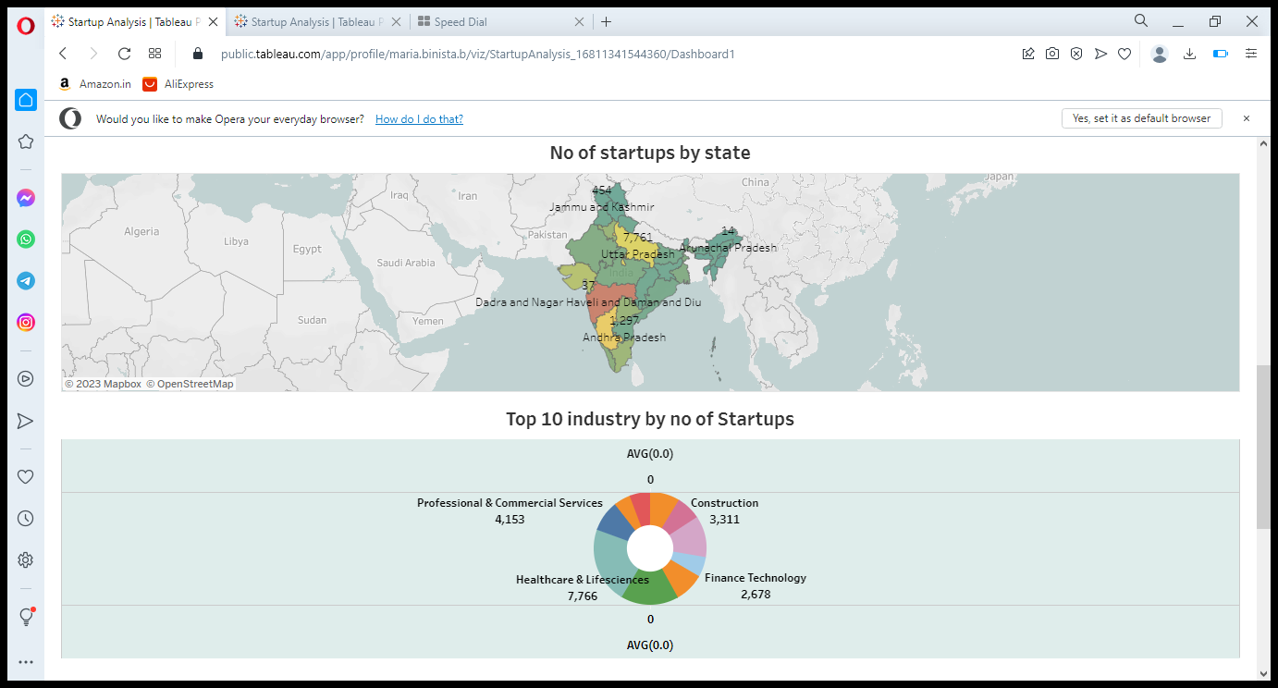

***3.2 Story Board:***

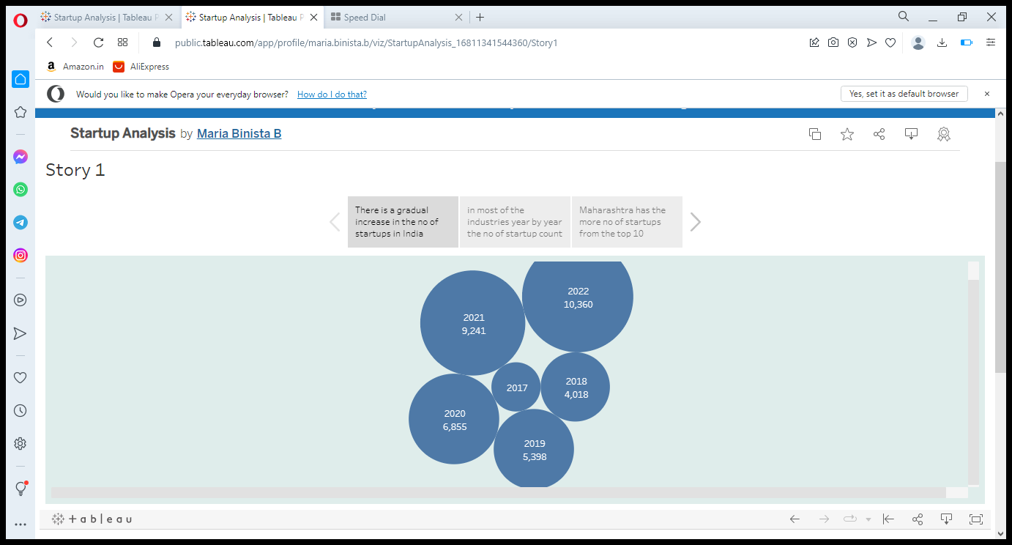

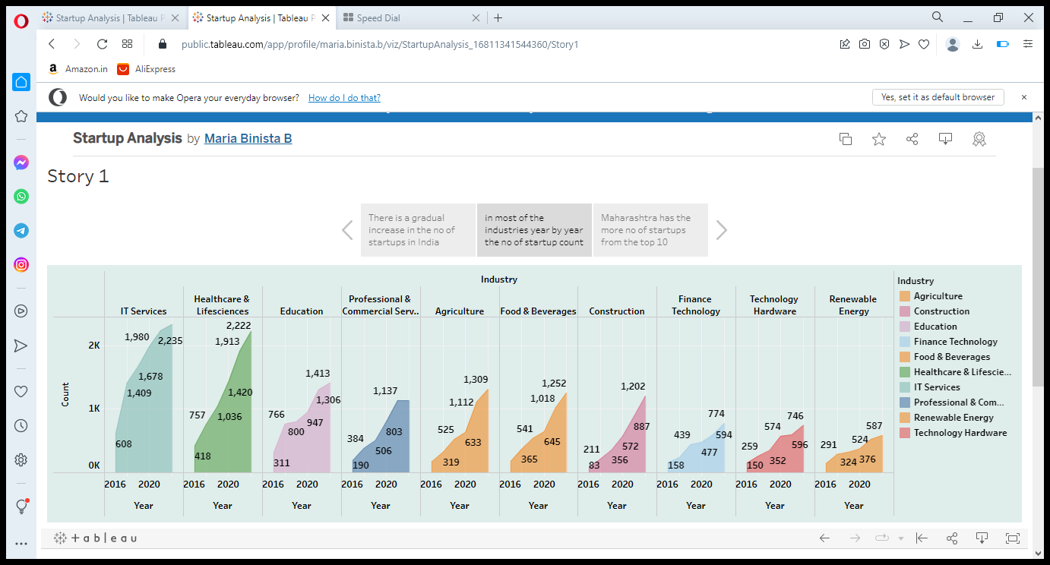

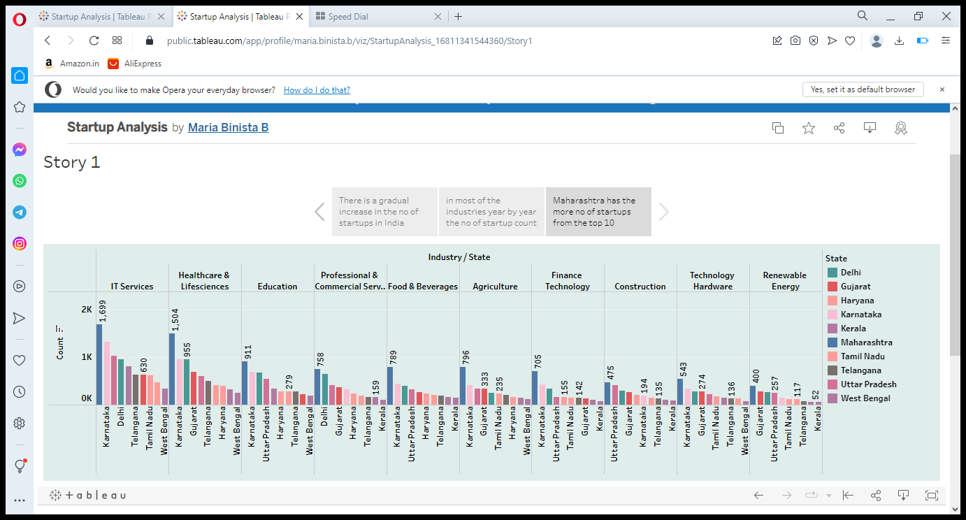

***4. WEB INTEGRATION:***

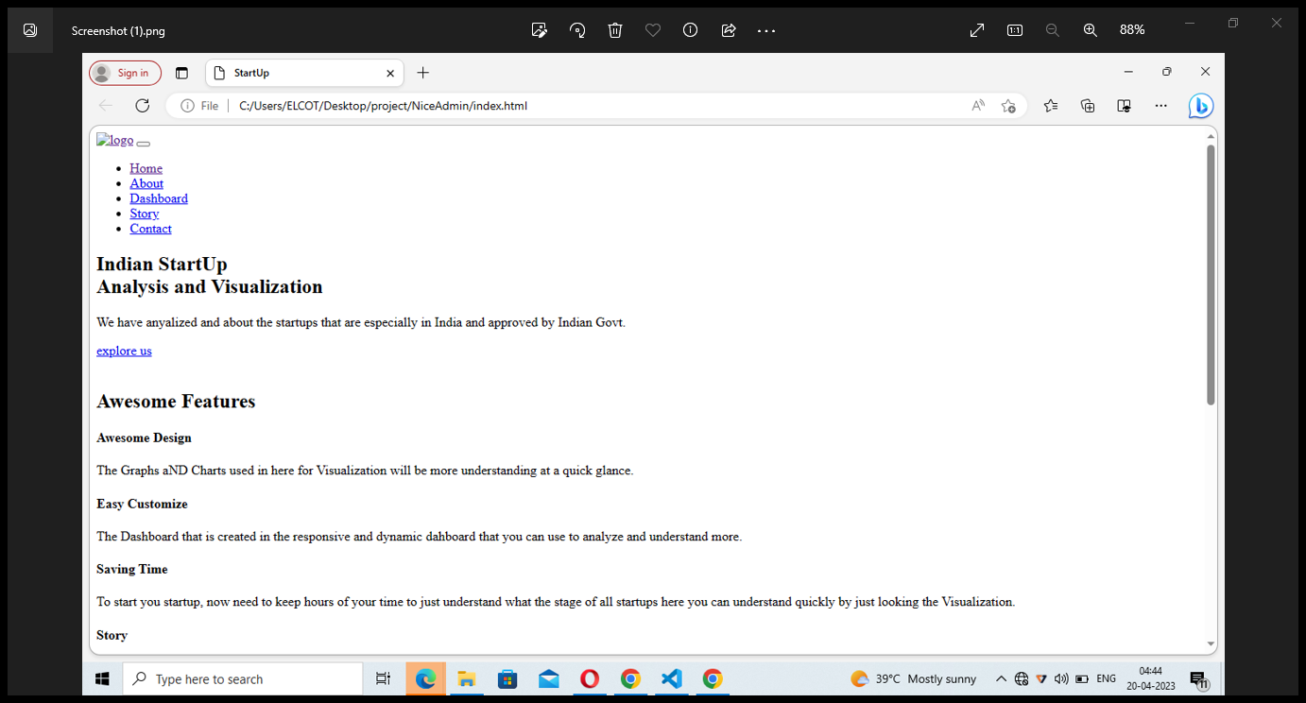

***5. ADVANTAGES AND DISADVANTAGES:***

***Advantages: Disadvantages:***

**1. Agility 1. Risk of Failure**

**2. Efficiency 2. Low Compensation**

**3. Team Culture 3. Poor Market Access**

**4. Personalization 4. Team Conflicts**

**5. Versatility 5. Lack of Resources**

**6. Flexibility 6. Lack of Process**

**7. Having Fun 7. Stressed Out**

***6. APPLICATIONS:***

The application of Big Data at startups makes these startups able to know the activities and know the trends that are mostly carried out by customers. With this they will be able to provide the right recommendations for their customers such as free shipping, vouchers and discounted prices and so on.

The way Big Data analyzes customer activity is after making a transaction. Looking at the transaction history carried out by this technology, it will provide recommendations that startups can do where this is still related to the transaction history. They do this innovation to satisfy customers and can only be done if the company implements Big Data in their company.

Make your business more advanced and grow by implementing Big Data in your company. You can use Big Data solutions from SOLTIUS to solve problems in your business and make them grow according to your expectations.

***7. CONCLUSION:***

A startup analysis is essential to the success of any startup business. It allows entrepreneurs to identify the key areas that need improvement and make necessary changes early on. Doing a startup analysis also allows startups to track their progress and ensure that they are on track to achieve their goals.

*8. FUTURE SCOPE:*

Indian startups are diverse, encompassing domains ranging from health and climate tech to clean energy and deep tech. They are well-positioned to take advantage of the opportunities presented by the sunrise sectors, industries poised for rapid growth and likely to play a significant role in driving the country’s economic progress.